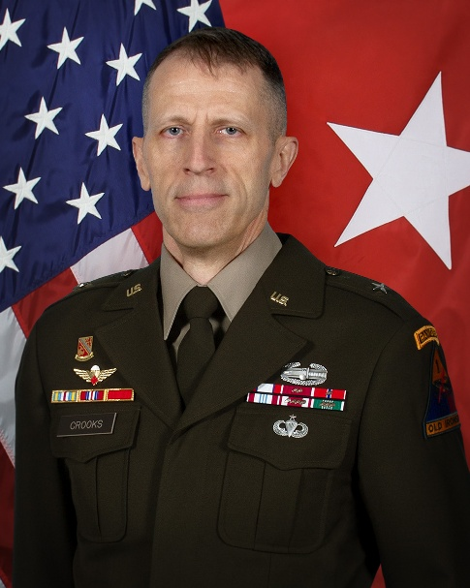
BG Rory A. Crooks
Capability Director
Deputy Chief of Staff, G-8

BG Rory Crooks leads the Headquarters, Department of the Army G-8 Capability Directorate (formerly Force Development Directorate), charged with planning, programming, and budget execution of resources to deliver required capabilities. Crooks served his company grade years as a Fire Support Officer for Airborne, Ranger, and Armor units, commanding in Korea and training units as an observer/controller in Germany. As a field grade officer, Crooks commanded within a Stryker Brigade Combat Team and deployed to both Iraq and Afghanistan. He served with 1st Special Forces Group (Airborne) and deployed with them in support of the Joint Special Operations Task Force-Philippines.
While serving as the 1st Infantry DIVARTY Commander, Crooks conducted three Warfighter Exercises. Additionally, he served with the NATO Special Operations Component Command/Special Operations Joint Task Force-Afghanistan and later as the V Corps Chief of Staff, deploying this headquarters to Europe ahead of the full-scale Russian invasion of Ukraine. BG Crooks was the Director of the Long Range Precision Fires Cross Functional Team, US Army Futures Command before assuming his last position as Deputy Commanding General-Operations of 1st Armored Division, Fort Bliss, TX.
He holds a B.S. in Civil Engineering from Washington State University, a Master of Military Arts and Sciences, and a Master of Strategic Studies from the Army War College. BG Crooks and his wife, LTC (Ret) Lisa Crooks, have two sons.

