U.S. Army Institute for Religious Leadership
USA-IRL Commandant & Deputy Director
Chaplain (COL) Tom Helms
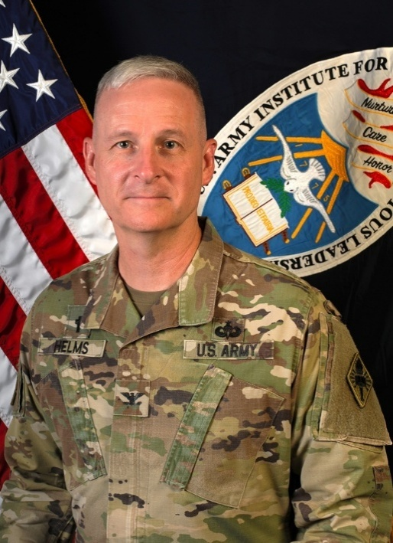
Chaplain Helms currently serves as the Commandant & Deputy Director of the US Army Institute for Religious Leadership. He joined the Army Reserve in 1986 and served as a Combat Medic and Combat Engineer. He attended OCS in 1993 and commissioned as a Military Intelligence Officer in the Utah National Guard. He was ordained an Elder in the Church of Jesus Christ of Latter-day Saints in 1987 and served from 1988-1990 as a minister in central Canada. After completing his graduate work at Brigham Young University, he was commissioned as an Army Chaplain in 1997.
He has served in a variety of assignments including Command Chaplain, United States Army Europe & Africa; Corps Chaplain, XVIII Airborne Corps; Executive Officer, Office Chief of Chaplains, Pentagon; Division Chaplain, 1st Armored Division, Fort Bliss, Texas; Brigade Chaplain, 504 PIR 82nd Airborne Division, Fort Bragg, North Carolina; Observer/Controller, National Training Center, Fort Irwin, California; Battalion Chaplain, 3-505 PIR 82nd Airborne Division, Fort Bragg North Carolina. His service includes two deployments to Iraq and one to Afghanistan. His most recent deployment was in 2022 with Task Force Dragon/Security Assistance Group Ukraine to Wiesbaden Germany.
Chaplain Helms has a Doctor of Ministry from Wesley Theological Seminary. He earned Bachelor and Masters Degrees from Brigham Young University. He completed a Masters of Public Policy and Management from the University of Pittsburgh with emphasis in Ethics and Security Studies. He is a graduate of Army Parachute and Jumpmaster Schools. His awards and decorations include the Legion of Merit with 2 OLC, Bronze Star Medal with OLC, the Defense Meritorious Service Medal, and the Meritorious Service Medal with 7 OLC.
Chaplain Helms was born and raised in Brevard, North Carolina. His wife, Andrea, is from Ogden, Utah. They have one daughter, and five sons. The family enjoys world-wide missions work, high adventure sports, aviation, and the outdoors.

