Find Your Frame Size

Every pair of glasses is a little different, so the size information may not always be in the same place. Look on the inside of your existing glasses frames. You will find the size information stamped either on the temple arm, or on the bridge, and sometimes on the earpiece.

You are looking for two two-digit numbers and one three-digit number. Here’s how to identify them:
Eye Size: a two-digit number in the 40 - 62 range
Bridge Size: a two-digit number in the 14 - 24 range
Temple size: a three-digit number in the 120 - 150 range

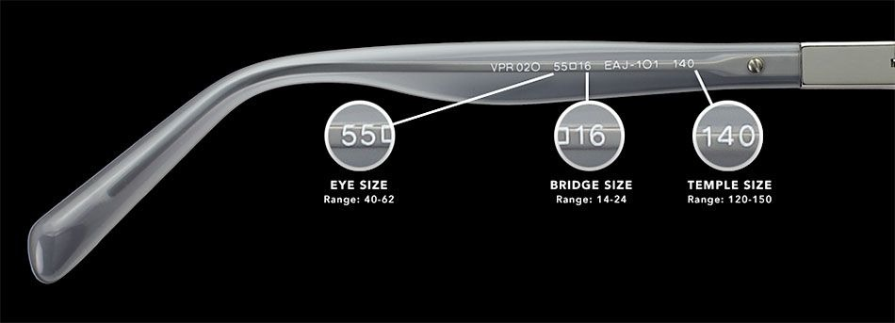
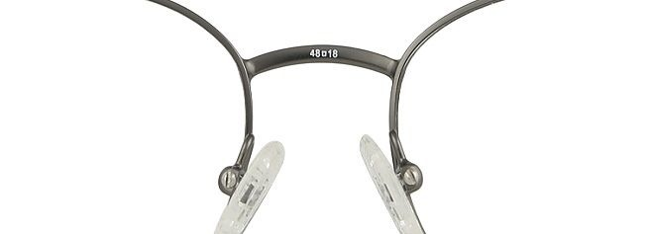

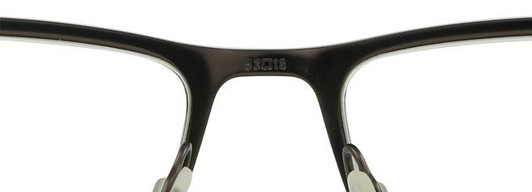
Find your Pupillary Distance
Download the app “glasseson” to your smartphone, following the prompts. Once you receive your results, email those to us.

Find your Vision RX-Prescription Visual Acuities
This can usually be obtained by calling your optometrist and requesting it over the phone.

Visual Acuities
This needs to be determined by an Optometrist or Medical provider
Corrected and Uncorrected for Near and Distant vision.
This can be documented on Page 2 of the DD Form 2808 by the Medical provider or in the comment box on the DD Form 771 by the Optometrist.
Example: 20/20 for perfect vision.

