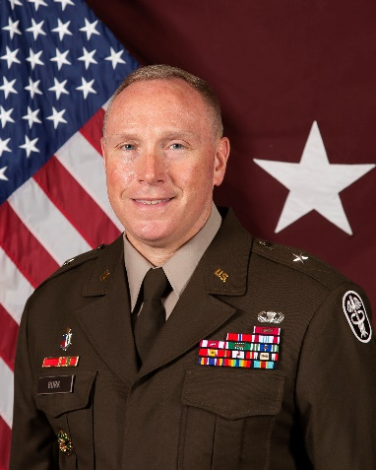U.S. Army Brig. Gen. James (Jamie) Burk is the Commanding General of the U.S. Army Medical Readiness Command, East, Director of the Defense Health Network East, and the 27th Chief of the U.S. Army Nurse Corps.  
  
Prior to his current role, BG Burk served as the Command Surgeon, U.S. Army Forces Command, from July 2023 to May 2025. His command assignments include the 261st Multi-Functional Medical Battalion at Fort Bragg, North Carolina; U.S. Army Medical Department Fort George G. Meade at Fort George G. Meade, Maryland; and the 44th Medical Brigade at Fort Bragg. Notable staff assignments include Executive Assistant to the Army’s Surgeon General, Falls Church, Virginia; Deputy Director for Nursing at Walter Reed National Military Medical Center, Bethesda, Maryland; and Assistant Deputy Medical Affairs, Office of the Assistant Secretary of the Army (Manpower and Reserve Affairs), Washington, D.C.

BG Burk is a native of Church Hill, Tennessee, and entered active duty in the U.S. Army in 1995. He received his commission from Army ROTC after graduating from East Tennessee State University with a Bachelor of Science in Nursing.

His past assignments include being an Emergency Nurse, 86th Combat Support Hospital, Fort Campbell, Kentucky; Emergency Nurse and Head Nurse, Leonard Wood Army Community Hospital, Fort Leonard Wood, Missouri; Brigade Nurse Recruiting Officer, 3rd Brigade, 4th Region ROTC Headquarters, Presidio of Monterey, California; Medical Operations Officer, 261st Area Support Medical Battalion; Commander, Headquarters and Headquarters Detachment, 261st ASMB; Emergency Department Head Nurse, Womack Army Medical Center, Fort Bragg; Assignments Officer, Army Nurse Branch, U.S. Army Human Resource Command, Fort Knox, Kentucky.

He deployed with the 261st ASMB as the detachment commander in support of Operation Iraqi Freedom and with the 274th Forward Surgical Team as an emergency nurse in support of OIF and Operation Enduring Freedom.

BG Burk graduated from the U.S. Army Medical Department Officer Basic and Advanced Course, the Combined Arms and Services Staff School, the Intermediate Level Education course, and the U.S. Army War College. He also holds a Master of Strategic Studies from the U.S. Army War College and a Master of Science degree in Health Services Management from Touro University International. BG Burk maintains certification as a board-certified emergency nurse.

His awards and decorations include the Legion of Merit with two oak leaf clusters, Bronze Star, Defense Meritorious Service Medal, Meritorious Service Medal with one silver leaf cluster, Army Commendation Medal with three OLCs, Army Achievement Award with one OLC, National Defense Service Ribbon, Iraqi Campaign Medal, Afghanistan Campaign Medal, Army Overseas Ribbon, and the Army Service Ribbon. He is authorized to wear the Army Staff Identification Badge and the Parachutist Badge. BG Burk is a member of the Order of Military Medical Merit.