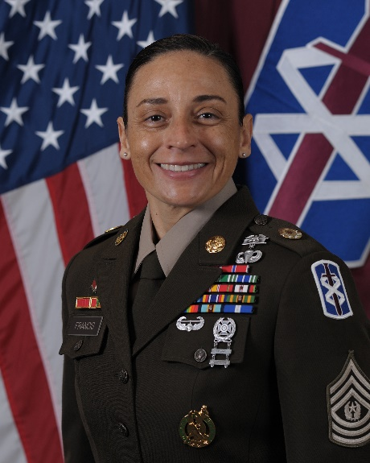

COMMAND SERGEANT MAJOR JENNIFER A. FRANCIS

COMMAND SERGEANT MAJOR

18TH THEATER MEDICAL COMMAND

Command Sergeant Major Jennifer A. Francis enlisted in the U.S. Army as a Pharmacy Specialist (68Q) and attended basic training at Fort Leonard Wood, Missouri, and Advanced Individual Training at Fort Sam Houston, Texas.

CSM Francis’s military education includes all levels of Noncommissioned Officer Professional Development Study to include Class 65 of the U.S. Army Sergeants

Major Academy. She has attended numerous functional courses to include Pharmacy Sterile Products Course, Pregnancy and Postpartum Physical Training Course, Recruiting and Retention School, Sabalauski Air Assault School, First Sergeant Course, Master Resilience Trainer Course, Division Surgeon Course, and Health Services, Plans, Operations, Intelligence, Security and Training.

CSM Francis’s military career includes assignments as a Pharmacy Technician, General Leonard Wood Army Community Hospital, Fort Leonard Wood; noncommissioned officer-in-charge for the Inpatient Pharmacy, Carl R. Darnall Army Medical Center, Fort Hood, Texas; NCOIC of the Outpatient Pharmacy, Kaiserslautern, Germany; NCOIC of Supply and Support and NCOIC of the Inpatient Pharmacy, Landstuhl Regional Medical Center, Germany; active duty Army recruiter, Phoenix Recruiting Battalion, Phoenix, Arizona; senior pharmacy NCOIC, S-4 NCOIC, and Alpha Company First Sergeant, 10th Combat Support Hospital, Fort Carson, Colorado; Advanced Individual Training First Sergeant – Bravo Company, 264th Medical Battalion, Joint Base San Antonio-Fort Sam Houston; Command Sergeant Major, 421st Medical Battalion (Multifunctional). Baumholder, Germany; Command Sergeant Major, 1st Medical Brigade, Fort Hood; Command Sergeant Major, Medical Professional Training Brigade, U.S. Army Medical Center of Excellence/Training and Doctrine Command, JBSA-Fort Sam Houston; Sergeant Major, U.S. Army Institute of Surgical Research, JBSA-Fort Sam Houston; Sergeant Major, Army Recovery Care Program, Falls Church, Virginia. Her previous assignment was Command Sergeant Major, Medical Readiness Command, West.

CSM Francis’s deployments include 12 months in Afghanistan with the 10th Combat Support Hospital in support of Operation Enduring Freedom and nine months in Qatar with the 1st Medical Brigade in support of Operation Spartan Shield.

Her civilian education includes an associate degree from Eastern Arizona Community College, a bachelor’s degree in Health Services Administration from Baker University and a Master of Public Administration/ Emergency Services from Columbia Southern University.

CSM Francis’s awards and decorations include Legion of Merit (with one oak leaf cluster), Bronze Star, Meritorious Service Medal (with six oak leaf clusters). Army Commendation Medal, Army Achievement Medal (with five oak leaf cluster), Good Conduct Medal (seven awards), National Defense Service Medal, Afghanistan Campaign Medal, Global War on Terrorism Expeditionary Medal, Global War on Terrorism Service Medal, Noncommissioned Officer Professional Development Ribbon (with Numeral 5), Army Service Ribbon, Overseas Service Ribbon (with Numeral 5). NATO Meritorious Service Medal, and the Meritorious Unit Citation. Her badges include the Gold Recruiter Badge, Expert Field Medical Badge, Air Assault Badge, Parachute Badge, Basic Marksmanship Qualification Badge, Drivers Badge, German Armed Forces Marksmanship Badge (Gold), and the German Armed Forces Proficiency Badge (Gold). She has also earned the United States Army Recruiter Ring, Glenn E. Morrell Medallion, and the Order of Military Merit (O2M3).