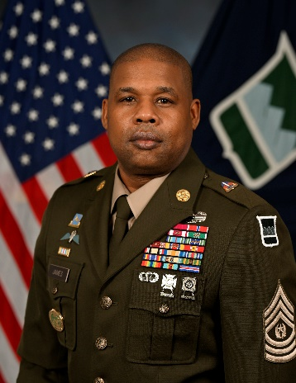Command Sergeant Major Rogelio A. James Jr.

Command Sergeant Major Rogelio James Jr., a native of Queens New York, entered the U.S. Army on 16 November 1993. He received his Basic Combat Training at Fort Leonard Wood, Missouri and Advanced Individual Training at Fort Huachuca, Arizona. Upon graduation he was awarded the primary Military Occupational Specialty (MOS) of 96B Military Intelligence Analyst. He transitioned into the U.S. Army Reserve on 25 February 2000 where he continues to serve Americas Warrior Citizens.

On 3 February 2025, Command Sergeant Major James was selected as the Command Sergeant Major (CSM) of the 80th Training Command (The Army School System).

Prior to this assignment he has held every leadership position from Intelligence Sergeant to Sergeant Major. His previous assignments include CSM 100th Training Division, CSM 335th Signal Command (Theater) (Provisional). CSM Army Reserve Cyber Protection Brigade, CSM 244th Expeditionary Combat Aviation Brigade. CSM 310th Military Police Battalion, CSM 392d Expeditionary Signal Battalion. Director of Instruction SGM (for MI NCOES) 6-98th RGT (MI), Chief Instructor 6-98th RGT. First Sergeant, 3-385th RGT (IET), Chief Intelligence Sergeant (Multinational Support Transition Command Iraqi). Senior Drill Sergeant 3rd Training Brigade, Fort Leonard Wood Missouri. S-2 NCOIC 63rd Ordnance Battalion (EOD), Intelligence Sergeant, 1-82d Aviation Battalion (Attack), Intelligence Analyst 82d Aviation Brigade, Fort Liberty (Formerly Fort Bragg) NC, and three overseas deployments in support of OIF, OEF, OSS and OIR.

His military schools include the Nominative Leaders Course, the Battalion/ Brigade Pre-Command Course, The Pre-Commandants Course, The Army Schools System Leader Course, the United States Army Sergeants Major Course (Resident Class 61.) Drill Sergeant School, Battle Staff Course, Army Basic Instructor Course, Small Group Instructor Course, Equal Opportunity Leader Course and Basic Airborne School.

CSM James’ awards and decorations include the Legion of Merit (2 OLC), Bronze Star Medal, Meritorious Service Medal (2 OLC), Army Commendation Medal (2 OLC), Army Achievement Medal (4 OLC), Joint Service Achievement Medal, Army Good Conduct Medal, Army Reserve Campaign Medal (2 OLC), National Defense Service Medal, Armed Forces Reserve Medal (with M-Device and Hourglass), Global War on Terrorism Medal, NCO Professional Development Ribbon (Numeral 5), Army Service Ribbon, and the Joint Unit Meritorious Service Award. He has also earned the Combat Action Badge, Parachutist Badge, Drill Sergeant Badge, Driver Badge, and British foreign Jump Wings.

He holds a Master of Arts from the University of Texas at EL Paso, a Master of Science in Criminal Justice, an Associate degree in Business administration and a Bachelor’s degree in Liberal Arts and Science from Excelsior College.

In his civilian career, he is a Retired Detective Investigator for the New York City Police Department and currently a Supervisory Staff Administrator within the USAR.