BRIGADIER GENERAL YOLONDA "YR" SUMMONS
Commanding General, Medical Readiness Command, West
Director, Defense Health Network, West

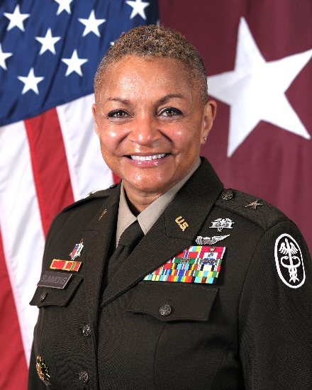
Brigadier General YR Summons commissioned in May of 1992. She graduated from Ouachita Baptist University, Arkadelphia, Arkansas. She entered active duty in October of 1993.
Her assignments include: Director for Policy and Force Integration, HQDA OTSG and the Deputy Chief of Staff for Operations, G-3/5/7, USAMEDCOM, Falls Church, Virginia; Special Assistant to the Deputy Surgeon General/Surgeon General Transition Team Lead at the Defense Health Headquarters, Falls Church, Virginia; 62nd Medical Brigade Commander, Fort Lewis, Washington; Deputy Corps Chief, Medical Service Corps; Commander, Supreme Headquarters Allied Powers Europe (SHAPE) Clinic and Brussels Army Health Clinic Commander, Mon, Belgium; Chief and Colonel Assignment Officer, Medical Service Corps Branch, Human Resources Command, Fort Knox, Kentucky; Executive Officer, United States Army Surgeon General at the Defense Health Headquarters, Falls Church, Virginia; Assistance Executive Officer, United States Army Surgeon General at the Defense Health Headquarters, Falls Church, Virginia; Battalion Commander, Northern Regional Medical Command, Fort Belvoir, Virginia; Army Medical Department Policy Integrator on the Army Staff at the Pentagon, Washington, District of Columbia; Troop Commander/DCSPER, United States Army Medical Research and Materiel Command at Fort Detrick, Maryland; Brigade S-1, 62nd Medical Brigade, Fort Lewis, Washington/Task Force S-1, Joint Medical Task Force, I Corps OPERATION IRAQI FREEDOM, Iraq; Student, United States Army Command and General Staff College, Fort Leavenworth, Kansas; Brigade G-3 Air, 30th Medical Brigade, Heidelberg, Germany; Battalion S-1, 421st Evacuation Battalion, Wiesbaden, Germany; HHC Company Commander for the 62nd Medical Brigade, Fort Lewis, Washington.
Operational Assignments include DOD COVID-19 RESPONSE (Texas); Brigade S-1, Joint Medical Task Force, I CORPS,
OPERATION IRAQI FREEDOM, Iraq; Battalion S-1, 421st Medical Evacuation Battalion, 30th Medical Brigade, V Corps, OPERATION IRAQI FREEDOM, Iraq; Operations Platoon Leader, 54th Medical Evacuation, Company, 62nd Medical Brigade, OPERATION SOUTHERN WATCH, Kuwait.
Brigadier General Summons educational degrees are from Howard University School of Divinity – Doctorate (Ethics and Social
Justice); United States Army War College – Master of Strategic Studies; Chapman University – Master of Arts – Organizational
Leadership; and Ouachita Baptist University – Bachelor of Arts – Biology. Her military education includes The United States Army War College, United States Army Command and General Staff College, Combined Arms Service Staff School, and Army Medical Officer Basic and Advanced Courses.
Brigadier General Summons' decorations and badges include the Defense Superior Service Medal, Legion of Merit (with 1 Oak
Leaf Cluster); Bronze Star Medal, Meritorious Service Medal (with 8 Oak Leaf Clusters); Army Commendation Medal (with 3 Oak Leaf Clusters); Army Achievement Medal (with 3 Oak Leaf Clusters); Expert Field Medical Badge; Army Aviation Badge; Army Staff Identification Badge.
Brigadier General Summons is the first United States Army African American Female Medical Evacuation Pilot and the first female to command the SHAPE Healthcare Facility. She is a proud member of The Order of Military Medical Merit, The Order of Saint Michael, and Delta Sigma Theta Sorority, Incorporated. Lastly, she received the 2009 Karen Wagner Leadership Award and is a 2012 Arkansas Hall of Fame inductee.
Brigadier General Summons enjoys traveling with her partner, Dr. Renee K. Harrison and Satchmo, their Hungarian Vizsla. She also enjoys reading, golfing, laughing, and spending time with her family and mentees.

