COMMAND SERGEANT MAJOR DEDRAF T. BLASH
Command Sergeant Major
Medical Readiness Command, West
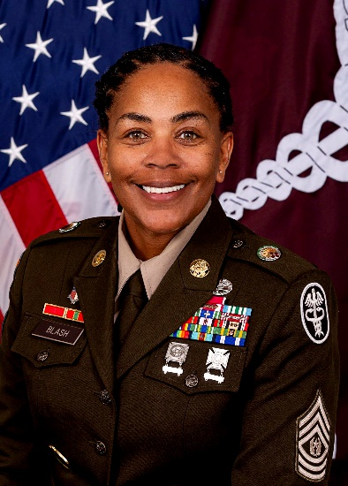
Command Sergeant Major Dedraf Blash entered the U.S. Army in January 2000. She completed Basic Training at Fort Leonard Wood, Missouri and Advance Individual Training at Fort Sam Houston, Texas for MOS 91B Combat Medical Specialist.
Command Sgt. Maj. Blash previous assignments include the 10th Combat Support Hospital at Fort Carson Colorado, 702nd Main Support Battalion at Camp Casey Korea, 565th Ground Ambulance Company at Fort Polk, Louisiana, 232nd Medical Battalion at Fort Sam Houston, Texas, McDonald Army Health Center at Fort Eustis, Virginia, US Army Africa at Vicenza, Italy, 27th Brigade Support Battalion at Fort Hood, Texas, 581st Area Support Medical Company at Fort Hood, 547th Area Support Medical Company at Fort Hood, Madigan Army Medical Center at Joint Base Lewis McChord, Regional Health Command Pacific at Joint Base Lewis McChord, and as the Sergeant Major for Schofield Barracks Health Clinic Schofield Barracks, Hawaii. She previously served as the Command Sergeant Major for the Weed Army Community Hospital at Fort Irwin, California, Command Senior Enlisted Leader at Alexander T. Augusta Military Medical Center, Fort Belvoir, Virginia, Command Sergeant Major at Brooke Army Medical Center, Joint Base San Antonio, Texas.
Command Sgt. Maj. Blash military education includes all levels of the Noncommissioned Officer Professional Development System including the United States Sergeant Major Academy (Class 68). She also attended Drill Sergeant School, Battle Staff Noncommissioned Officers Course, Battle Staff Instructor Course, Master Resiliency Trainer Course, SHARP Course, Basic Healthcare Administrative, Security Operations Certification Training Course, Joint Medical Executive Skills, and the Battalion and Brigade Pre-Command Course and Command Sergeant Major Development Course, AMEDD Pre-Command Course.
Command Sgt. Maj. Blash holds a Master’s in Science Management with a concentration in Organizational Leadership from Excelsior College graduating Summa Cum Laude, Doctor of Strategic Leadership from Liberty University, and a Juris Master’s in Health Law.
Command Sgt. Maj. Blash operational deployments include Iraq in support of OIF I and Operation Enduring Freedom in Afghanistan. Her awards and decorations include the Legion of Merit; Bronze Star Medal; Meritorious Service Medal, 6th Award; Army Commendation Medal, 8th Award, Joint Service Achievement Medal, Army Achievement Medal, 6th Award; Army Good Conduct Medal, 7th; Iraq Campaign Medal, National Defense Service Medal, Korea Defense Service Medal; Global War on Terrorism Service Medal; Global War on Terrorism Expeditionary; NATO Medal, Noncommissioned Officer Professional Development Ribbon with numeral 5; Army Service Ribbon; Overseas Service Ribbon with a numeral 4, Meritorious Unit Award, Drill Sergeant Badge and Combat Medical Badge.
Command Sgt. Maj. Blash is a member of the International Honors Society of Business, American Bar Association, Honorary member of the Sergeant Audie Murphy Club, 2010 John Teal Leadership Awardee and Order of Military Medical Merit.

