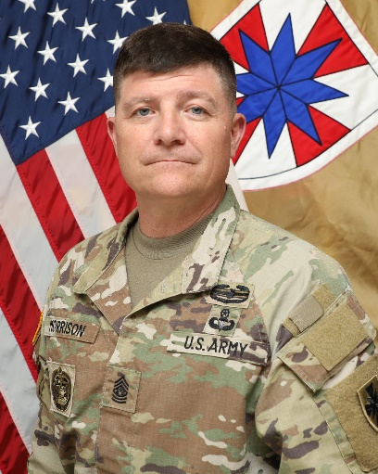**Command Sergeant Brian J. Morrison**

Command Sergeant Major

CSM Brian J. Morrison assumed the duties as the 8th Theater Sustainment Command, Command Sergeant Major on 18 September 2023. CSM Morrison enlisted in the Army in 1991 and has served on active duty for 30 years. He attended Basic Training and Light Wheeled Vehicle Mechanic (63B) School at Fort Jackson, South Carolina.

CSM Morrison’s assignments include Light Wheeled Vehicle Mechanic, Headquarters Support Company, 1st Battalion, 3rd Special Forces Group (Airborne), Fort Bragg, North Carolina; Shop Foreman, 82nd Military Police Company, Fort Bragg, North Carolina; Company Motor Sergeant, Delta Company, 102nd Military Intelligence Battalion, Camp Essayons, Korea; Battery Motor Sergeant, Bravo Battery 3/4th Air Defense Artillery Regiment, Fort Bragg, North Carolina; Senior Drill Sergeant, Delta Company, 187th Ordnance Battalion, Fort Jackson, South Carolina; First Sergeant, Alpha Company, 167th Support Battalion, Joint Base Elmendorf-Richardson, Alaska; First Sergeant, Easy Company, 725th Brigade Support Battalion, Joint Base Elmendorf-Richardson, Alaska; G4 Transportation Sergeant Major, I Corps, Fort Lewis, Washington; Command Sergeant Major, 725th Brigade Support Battalion, Joint Base Elmendorf-Richardson, Alaska; Command Sergeant Major, Group Support Battalion, 1st Special Forces Group (Airborne), Joint Base Lewis McChord, Washington; Command Sergeant Major, 402nd Army Field Support Brigade, Fort Shafter, Hawaii; G4 Sergeant Major, I Corps, Joint Base Lewis McChord, Washington, and Command Sergeant Major, Joint Munitions Command, Rock Island Arsenal, Illinois. He most recently served as Command Sergeant Major, Surface Deployment and Distribution Command, Scott Air Force Base, Illinois.

CSM Morrison’s military education includes all levels of Non-Commissioned Officer Education System courses. He is a graduate of the U.S. Army Sergeants Major Academy (Class 59). His additional military training includes: Vehicle Recovery School; Airborne School; Drill Sergeant School; Jumpmaster School; First Sergeants' Course; and the Command Sergeants' Major Course. His civilian education includes an Associate Degree in business management from Coastline Community College, Fountain Valley, California.

CSM Morrison’s awards and decorations include the Legion of Merit (1 Oak Leaf Cluster); Bronze Star Medal (1 Oak Leaf Cluster); Defense Meritorious Service Medal; Meritorious Service Medal (5 Oak Leaf Clusters); Army Commendation Medal (4 Oak Leaf Clusters); Army Achievement Medal (4 Oak Leaf Clusters); Army Good Conduct Medal (2 Silver Knots); National Defense Service Medal (2 Bronze Stars); Korean Defense Service Medal; Armed Forces Expeditionary Medal; Iraqi Campaign Medal (3 Bronze Stars); Global War on Terrorism Service Medal; Humanitarian Service Medal; NCO Professional Development Ribbon (Numeral 4); Overseas Ribbon (Numeral 4); Military Occupational Volunteer Service Medal; United Nations Medal (Haiti); Joint Meritorious Unit Award; Valorous Unit Award; Army Superior Unit Award; Combat Action Badge; Master Parachutist Badge; Drill Sergeant Badge; and the German, Tunisian, Canadian, and Australian Parachutist Badges. CSM Morrison has been awarded the Order of Samuel Sharpe from the U.S. Army Ordnance Corps and Order of Saint Barbara from the U.S. Army Artillery Corps.