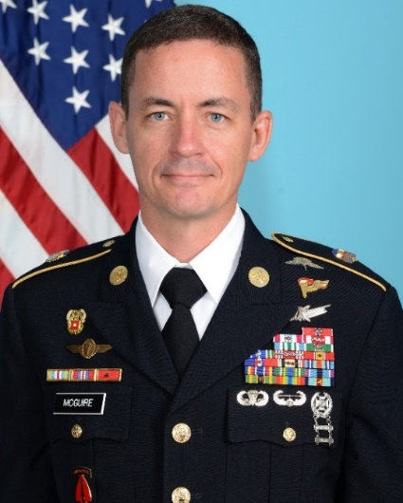
Command Sergeant Major Timothy D. McGuire is a native of Elk Rapids Michigan. He enlisted into the United States Army in January of 1995 as an Airborne Satellite Communications Operator-Maintainer.

Currently assigned as the incoming Command Sergeant Major for the 7th Signal Command (Theater), CSM McGuire has served in various positions and assignments throughout his career. These include: Satellite Operator/Maintainer in the 319th Military Intelligence Battalion (A), Fort Bragg, NC; Shift Supervisor in the 509th Signal Battalion, Camp Darby, Italy; Team Chief in the 112th Signal Battalion (SO)(A), Fort Bragg, NC; Communications NCO and Training Course Sergeant Major in the USAOMS, Washington DC; Chief Signal NCO in the 593rd Expeditionary Sustainment Command, Joint Base Lewis-McChord, WA; Chief Signal NCO and Operations Sergeant Major in the 19th Expeditionary Sustainment Command, Daegu, South Korea; the Command Sergeant Major for the 39th Strategic Signal Battalion, Daumerie, Belgium; FORSCOM Senior Information Systems Chief (G-6 SGM), Fort Bragg, NC and the Command Sergeant Major for the Joint Communications Support Element, MacDill AFB, FL.

He has deployed multiple times while attached to various Special Forces teams as well as the Joint Special Operations Command. His deployments have supported both combined and joint training operations as well as combat operations in locations throughout the world including South Korea, Kuwait, Iraq, the Philippines and Ghana.

His military education includes: Airborne School, SOC Jumpmaster Course, Air Assault School, Pathfinder School, Military Free Fall School, Satellite Network Controller Course, the Joint Communications Unit Special Operations Radio Operator Course, Survival, Evade, Resist and Escape (SERE-High Risk) Course, JFK Special Warfare Basic Instructor and Small Group Instructor. He is a graduate of the United States Army Sergeants Major Academy, Class 64 and the Nominative Leaders Course.

His technical training includes: Certified Ethical Hacker, Security+, Covert Electronic Surveillance, Tactical Data Acquisition, Digital Evidence Acquisition, Seized Computer Evidence Recovery, and Surveillance/Surveillance Detection Operations.

His military awards and decorations include the Joint Meritorious Unit Award, Valorous Unit Award, Meritorious Unit Commendation (1OLC), Army Superior Unit Award, Legion of Merit, Bronze Star Medal (2OLC), Defense Meritorious Service Medal (1OLC), Meritorious Service Medal (3OLC), Joint Service Commendation Medal, and the Army Commendation Medal (2OLC). He has earned the Military Freefall Badge, Pathfinder Badge, Master Parachutist Badge, Air Assault Badge, and the Basic Space Badge. He was also awarded the Venezuelan and German Parachutist Badges, the Netherlands Military Freefall Badge and the Belgian Army Physical Fitness Silver Award.

He has earned a Bachelor’s degree in Computer Management and Information Systems with Summa Cum Laude honors from the University of Maryland University College.

