Paul E. Biggs
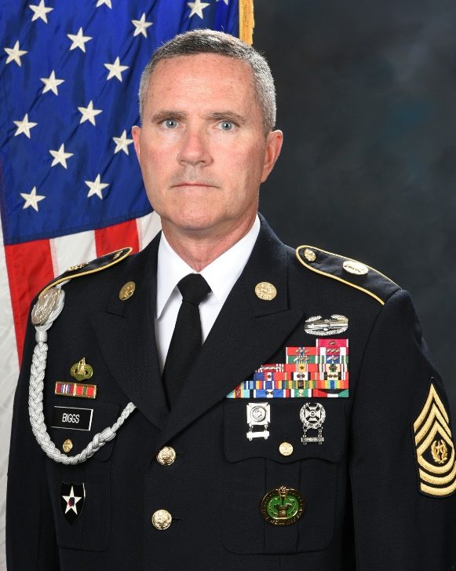
CSM, Futures and Concepts Center
Command Sgt. Maj. Paul E. Biggs joined the Army on April 21, 1988 and attended one-stop unit training at Ft. Knox, KY.
His duty assignments include 2d Battalion, 81st Armor Regiment, Erlangen, GE; 2nd Squadron, 3rd Armored Cavalry Regiment, Ft. Bliss, TX; 2nd Battalion, 64th Armor Regiment, Schweinfurt, GE; 1st Battalion, 33d Armor Regiment, Ft. Lewis, WA; 2d Battalion, 81st Armor Regiment, Ft. Knox, KY; 2nd Battalion, 63rd Armor Regiment (PSG/BN MG), Vilseck, GE; 3rd Battalion, 69th Armor Regiment (1SG), Ft. Stewart, GA; University of Washington ROTC, Seattle, WA; 2nd Battalion, 12th Field Artillery Regiment (OPS SGM), JBLM, WA; 2nd Battalion, 23d Infantry Regiment (OPS SGM), JBLM WA; 4th Battalion, 23d Infantry Regiment (CSM), JBLM, WA; 1st BDE, 1st AD (CSM), Ft. Bliss, TX; the Combined Security Transition Command-Afghanistan (CSEL) in Kabul, AFG; the Army Evaluation Center (SGM) as part of the Army Test and Evaluation Command; the Military District of Washington/Joint Force HQs-NCR (CSM), Ft. McNair, DC. He currently serves as the CSM of the Futures and Concepts Center (FCC) as part of Army Futures Command (AFC).

CSM Biggs' duty assignments include M1A1 armored crewman, gunner, tank commander, company master gunner, battalion master gunner, drill sergeant, platoon sergeant, first sergeant, senior military science instructor, operation’s sergeant major, battalion command sergeant major, brigade command sergeant major and SEL for CSTC-A. He has attended all levels of the Noncommissioned Officer Professional Development System. He has earned a Bachelor’s Degree in Finance from the University of Maryland. His operational deployments include Operation Desert Shield/Desert Storm, Kosovo (KFOR 4B), three deployments in support of Operation Iraqi Freedom, a deployment in support of Operation Enduring Freedom and a deployment to Operation Freedom’s Sentinel/Resolute Support.
CSM Biggs' awards and decorations include the Legion of Merit (2 OLC), Bronze Star Medal (3 OLC), the
Meritorious Service Medal (3 OLC), Army Commendation Medal (7 OLC), Army Achievement Medal (6 OLC),
Valorous Unit Award, Army Superior Unit Award, Good Conduct Medal, National Defense Service Medal,
Kosovo Campaign Medal, Southwest Asia Service Medal, Iraq Campaign Medal, Afghanistan Campaign
Medal, Global War on Terrorism Expeditionary Medal, Global War on Terrorism Service Medal,
Noncommissioned Officer Development Ribbon, Army Service Ribbon, Overseas Ribbon, Saudi Arabia Kuwait Liberation Medal, Kuwaiti Kuwait Liberation Medal, the NATO Medal, Drill Sergeant Badge, Driver's Badge and the Combat Action Badge. He has also been presented the Order of St. George, the Order of St. Maurice and the Order of St. Barbara.

